Child Theme Development

08 Child Theme dev

Place holder Screenshot

Tony Evans

See next page for screenshots of what your page should look like

# Menu

In this session create a menu wherever you would like one on your page.

To do this, open the functions.php file. Scroll down till you see the included code in the file.

//*********Building a menu called mychildtheme menu**********

function mychildtheme_register_menu() {

register_nav_menu('new-menu', __('My Really New Menu'));

}

add_action('init', 'mychildtheme_register_menu');

The above code is commented out in the file so that it does not start the menu creation yet. Have a look at the Admin panel to see what is happening with the menu in the Child Twenty Seventeen theme.

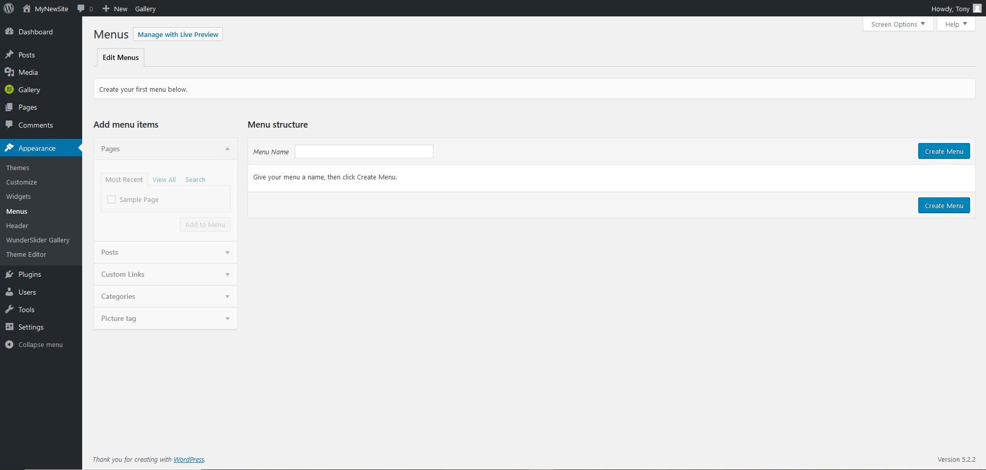

There are no menus allocated in the Child theme so far. Un-comment the code in the functions file and see what happens in this menu area.



Nothing!

Don’t panic, the code is there. Because the theme does not have any menus setup, it needs a menu set so that you can manage where it goes.

Create a menu in this area and see what happens. You should see your menu appear in the list. There is also a Manage tab that has now appeared next to the Edit Menus tab.

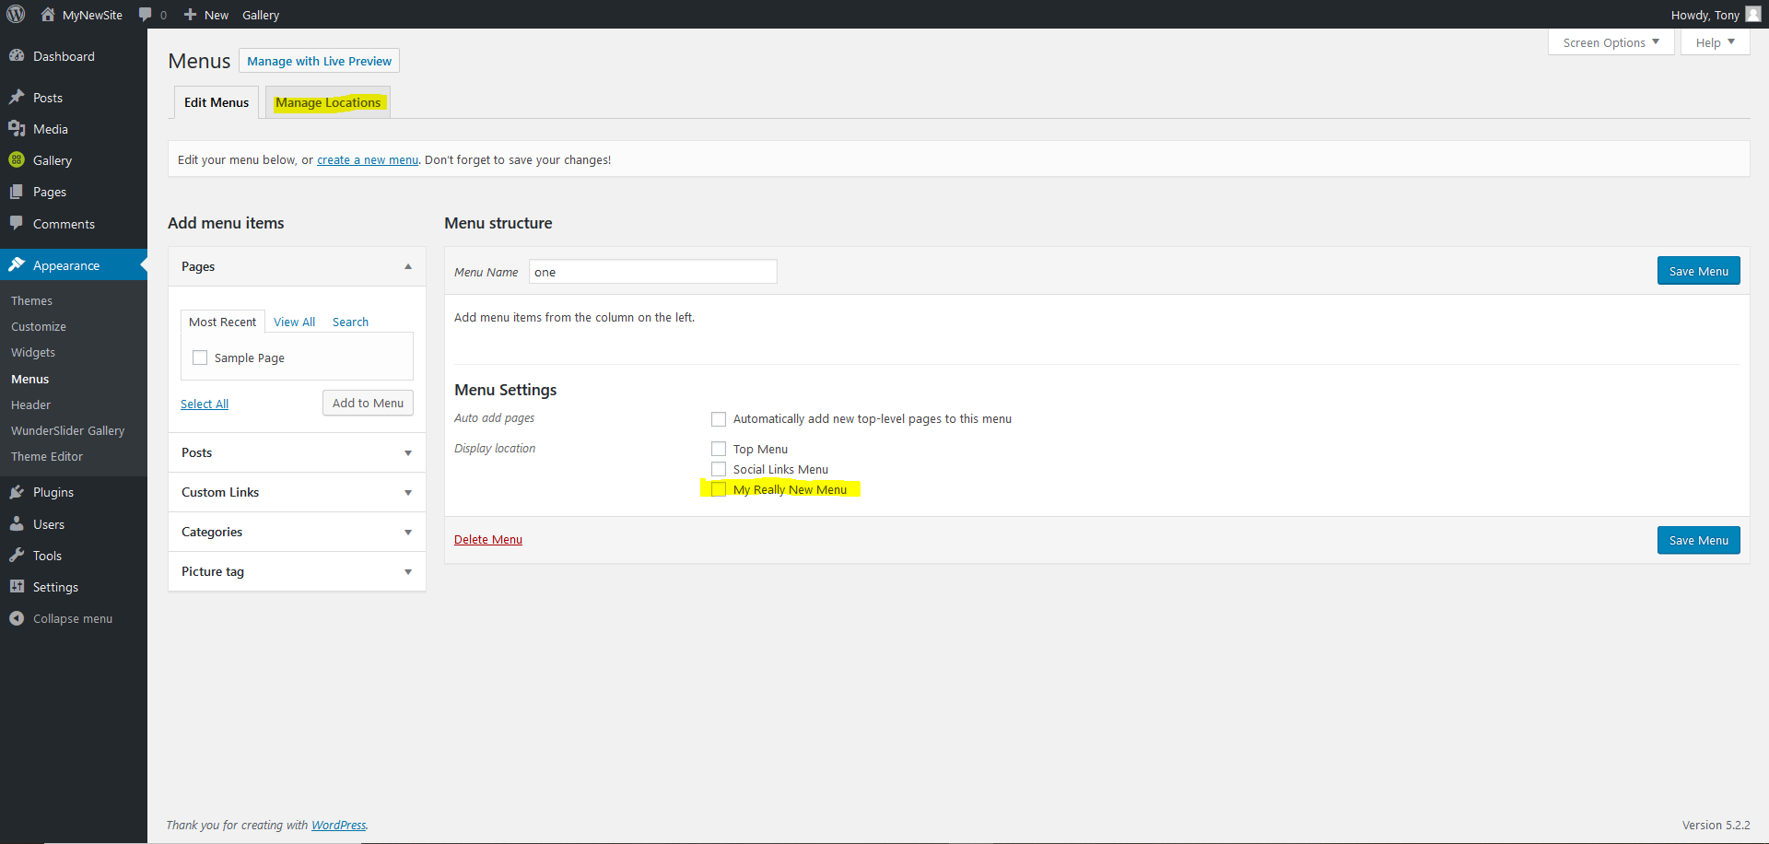

Click the Manage tab and see what listing is there. You should see your menu in the list.

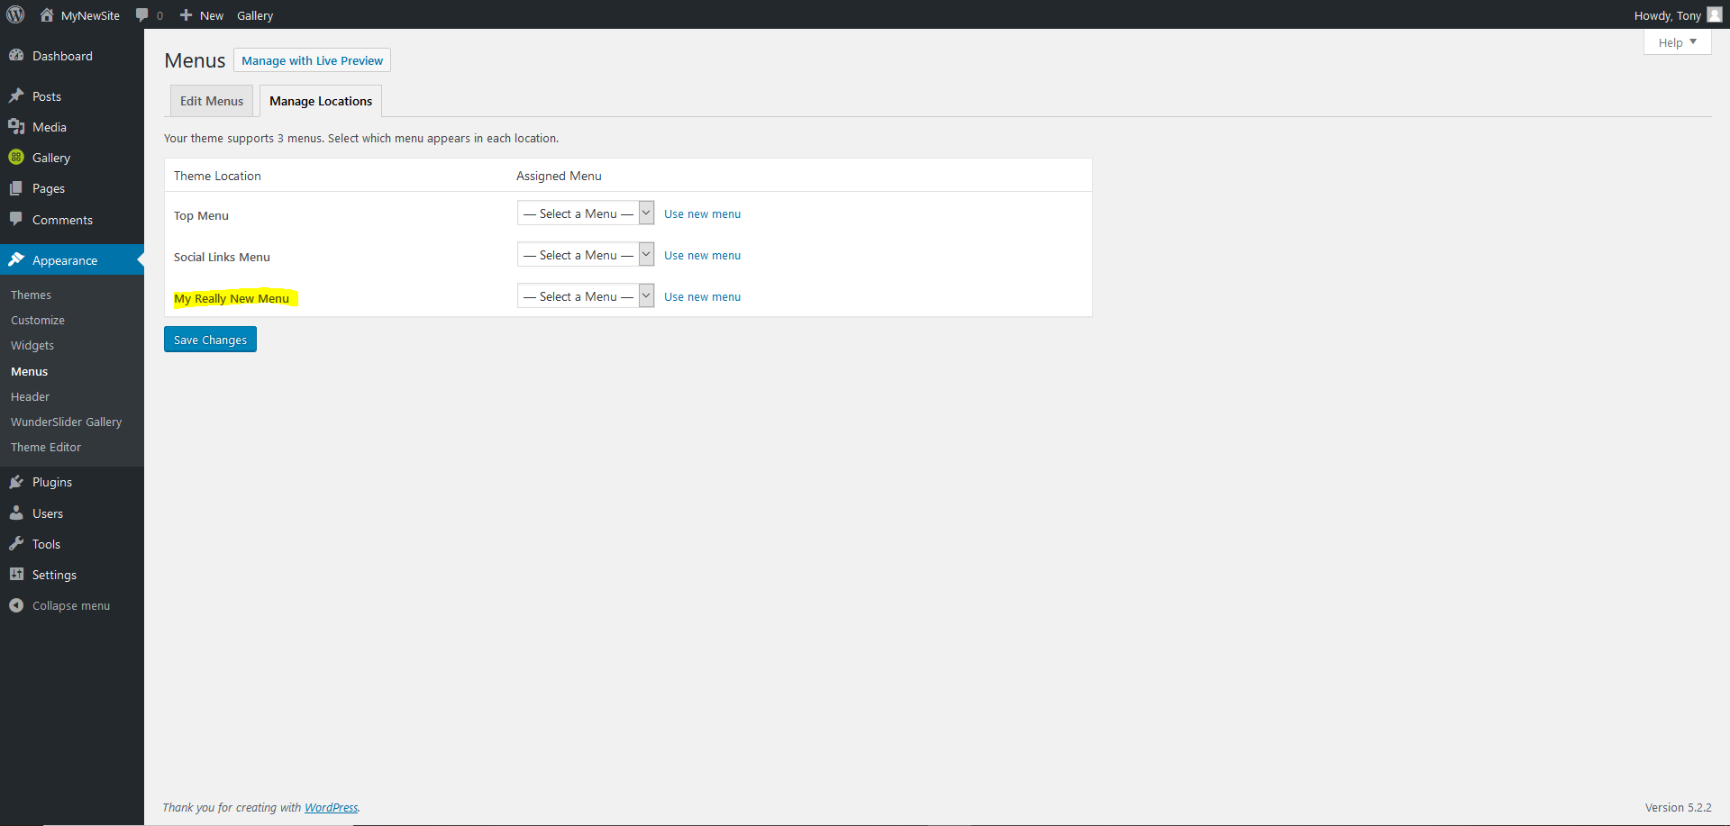

The **next step** is to place the menu where you want on the page.

To show a proof of concept pick out an area that could work as a menu. For the TwentySeventeen Child theme, there is an image that is used to slide down and see the rest of the page. An ideal place could be just under the image. To find this you will need to look through the code in Developer Tools in the browser.

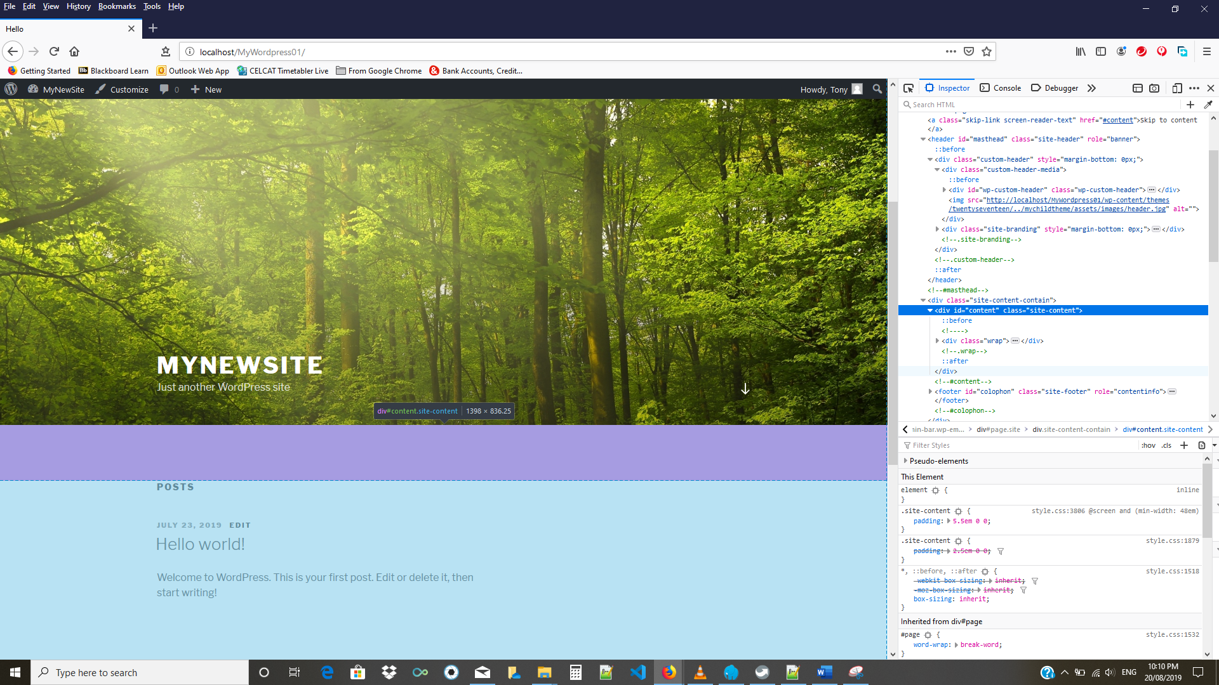

The html code for this area is in the header.php file. If you look at the code, there is the end header tag </header> just before a couple of lines down <div id=”content” class=”site-content”>.

Locate and open the header.php file and un-comment the following line

<?php wp_nav_menu(array('theme_location' => 'new-menu')); ?>

Save the file and then refresh the WordPress page. You should see a rather un impressive menu appear.

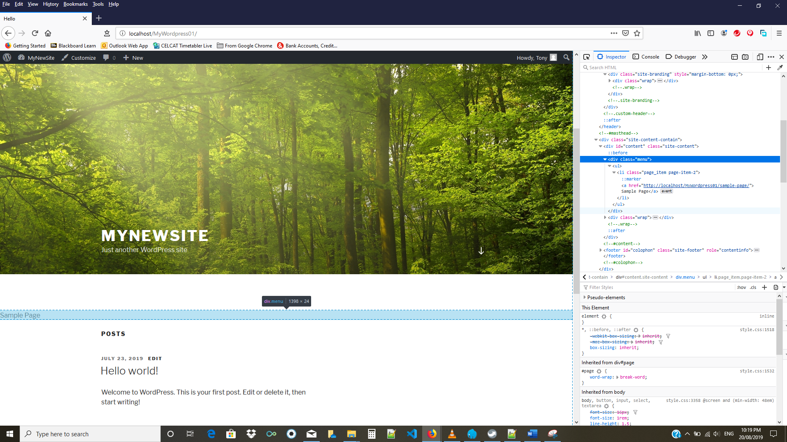

The menu will look better when you add more pages to your site. You can also target the menu in the css to change the appearance.

**This session has included the folders and file with modifications.**

**You only need to add the widget to the widget area in the admin panel.**